|  |
| --- |
| DOMINANT Opto Technologies Sdn. Bhd. |
| User Guide Purchase Request System |
| Purchase Request System User Guide |

|  |
| --- |
| Que  6-6-2022 |

**Log in to system**

1. Open browser and go to <http://prs.dominant-semi.com/>
2. 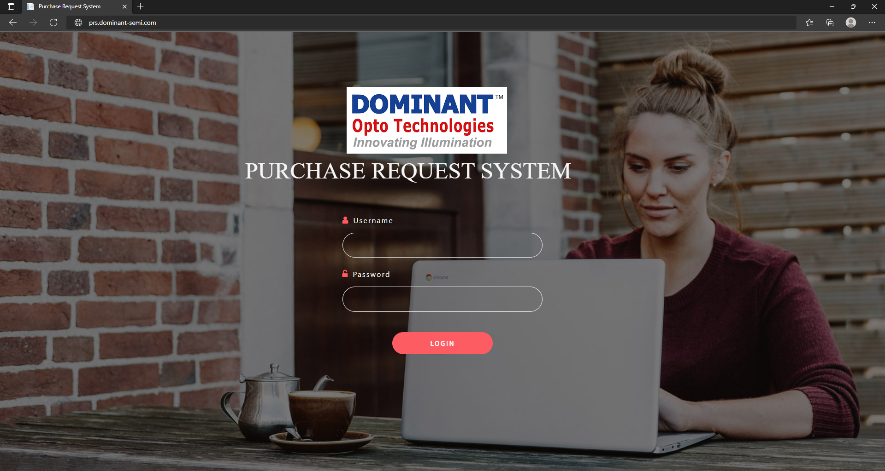
3. Above is the PRS website login form.
4. Login using your ***PC Username and password.***
5. For normal user; system will direct to User Purchase Request page.
6. 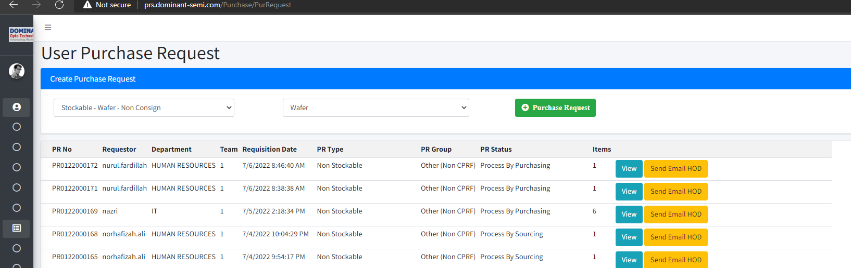
7. System will only show your department Purchase Request.
8. To add new PR , please select PR type.
9. 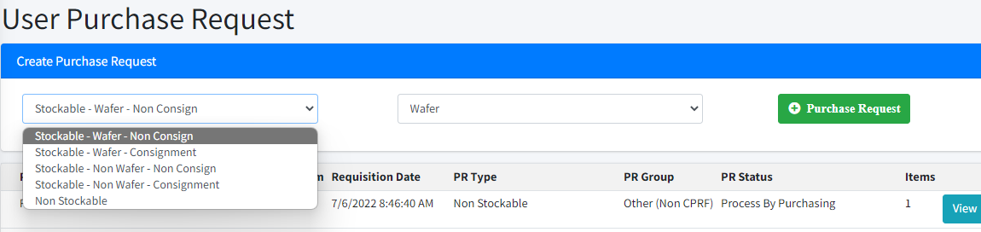
10. 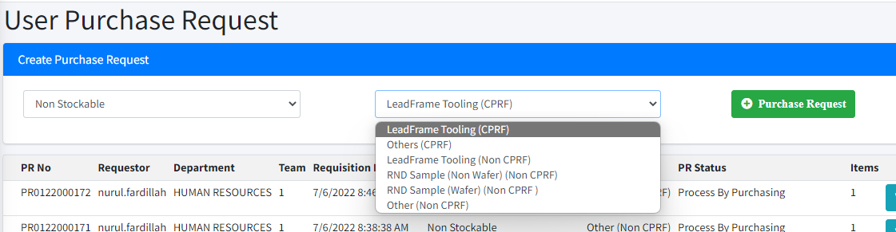
11. Click on Purchase Request button, new PR will be load in your PR list.
12. 
13. Click on Add Details button to proceed.

***Add PR Details***

1. 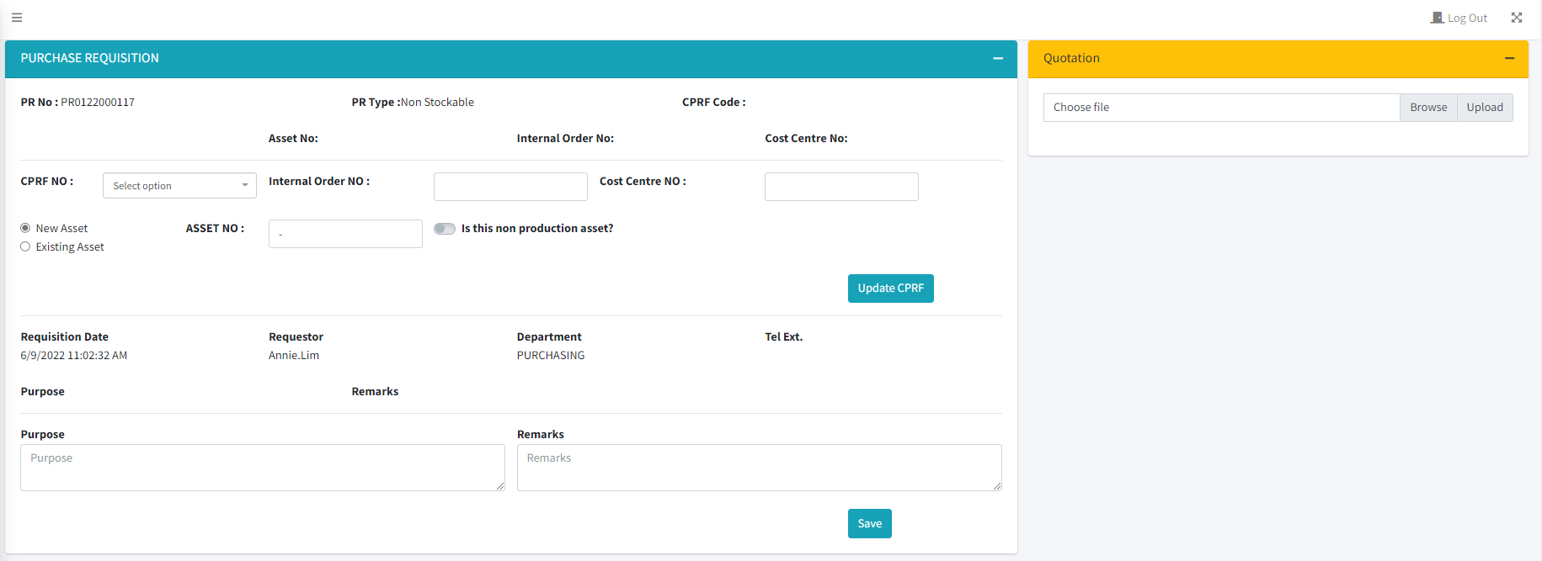
2. For PR type ; Non stockable (CPRF) ; user are required to update CPRF details .
3. If your CPRF No is not in the list ; please contact purchasing department.
4. Fill up the form and click on Update CPRF button.
5. The information updated will be shown above CPRF form.
6. 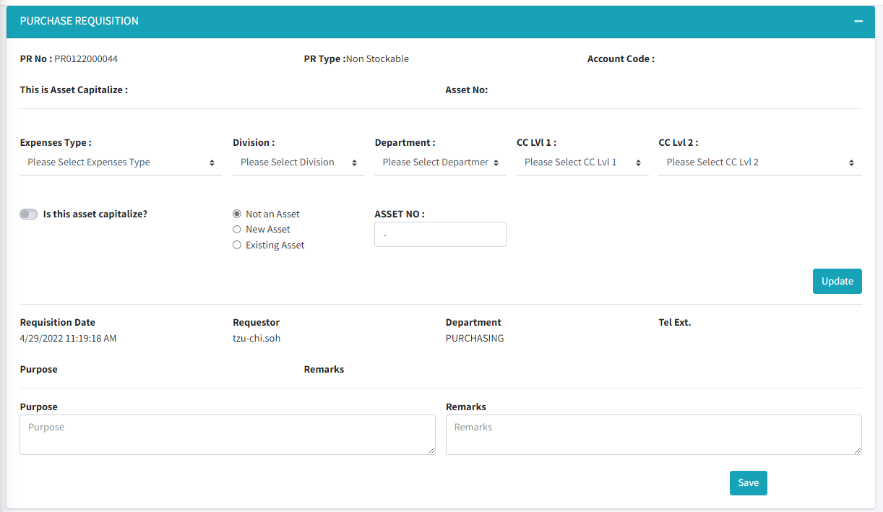
7. As for non CPRF ; user are required to update Account No details.
8. Please fill up the form and proceed to click on Update button.
9. 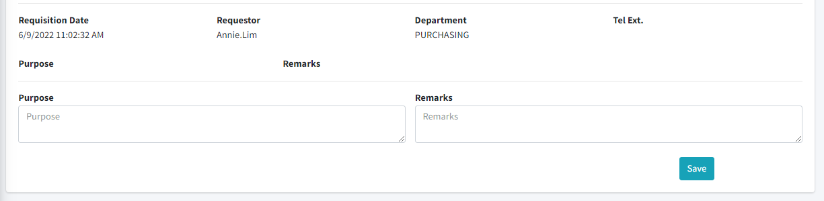
10. 2nd form is to update Purpose and Remarks .
11. Please fill up the form and click on save button to continue.
12. 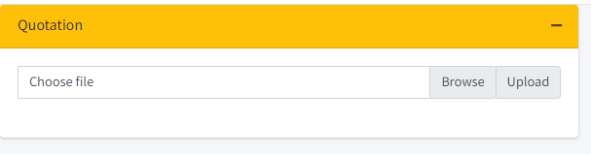
13. 3rd form is for user to upload the quotation.
14. Click browse; the browse dialog will open.
15. Choose the file
16. Click on upload button to upload the file in system.
17. 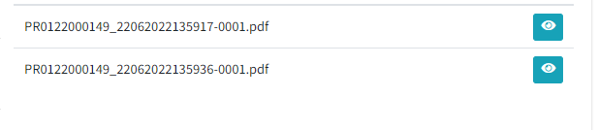
18. The file uploaded will be shown below.
19. 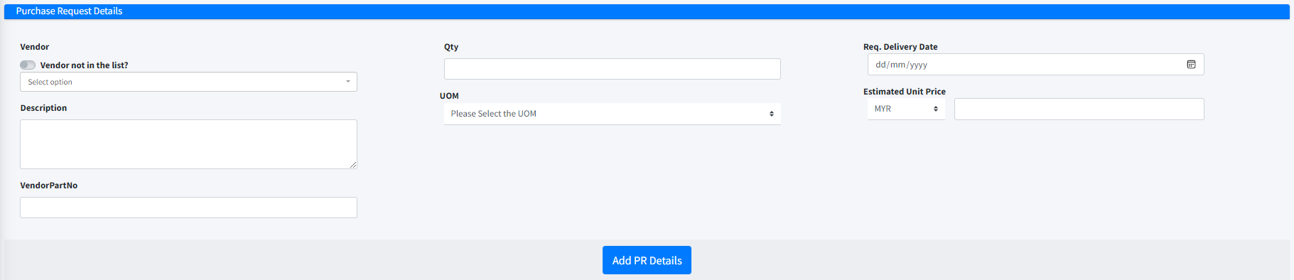
20. 4th form for the user to add PR details item.
21. 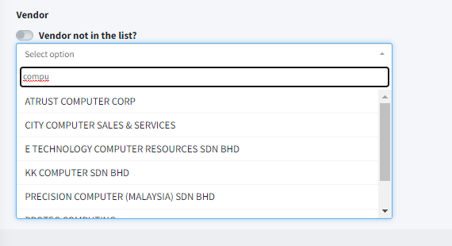
22. Please search the vendor in the list.
23. Provided if the vendor is not in the list.
24. Click on toggle button ; vendor not in the list?
25. You will be required to type in vendor name.
26. Fill up the rest of form and click on Add PR Details.
27. The new line will appear in PR Details List below the form.
28. After all the item has been key-in.
29. Click on Return To Main PR.
30. It will bring user back to Main PR List.
31. 
32. Send button; to send the complete PR to HOD for approval.
33. Delete button; to delete the PR. – Delete PR only can be done if the PR status is new.
34. View button; to view the PR.

***HOD Approval***

1. 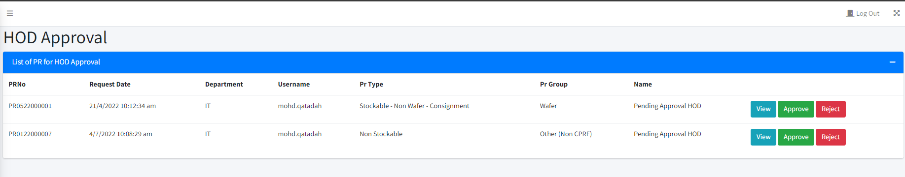
2. HOD will view List of PR for their department.
3. View; to view PR.
4. 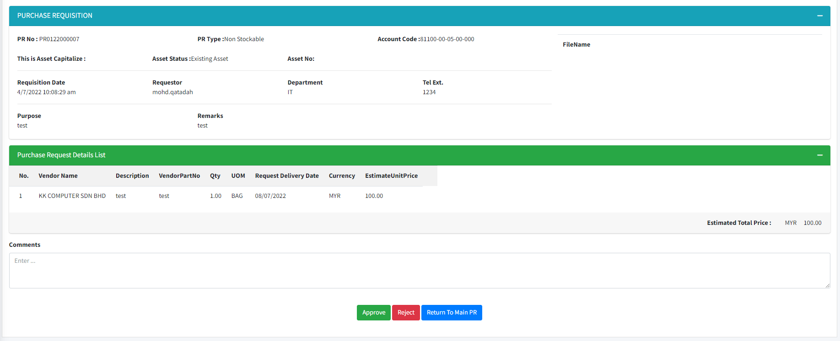
5. Approve; PR will be approved and send to purchasing department.
6. Reject; key-in the comment. PR will be send back to user and comment will appear in user’s PR list.
7. Return to Main PR; will bring back to HOD PR Approval list.